**Python-Django Internship Report**

**Personal Details**

Name : Rutvi Patel

College Name : Silver Oak College of Engg. & Tech.

Degree : Bachelor of Engineering

Semester : 7th

GitHub URL : <https://github.com/akashpadhiyar>

**Company Details**

Company Name : Akash Technolabs

External Guide : Mr. Akash Padhiyar

Training Duration : 25-05-2021 to 21-06-2021

**Index**

|  |  |  |
| --- | --- | --- |
| **Day** | **Task Detail** | **Page Name** |
| 1 | Basic programming with HTML and CSS. | 3 |
| 2 | Basic programming with Python. (variables, datatypes, lists, tuples, dictionary etc.) | 4 |
| 3 | Conditional statements, Looping statements, Break & Continue, Pass statements. | 5 |
| 4 | User defined Functions and Functional Arguments | 6 |
| 5 | OOPs Concepts (class, constructor, inheritance) | 7 |
| 6 | Basics of Django with its applications & Installation of Django. | 8 |
| 7 | Project creation, Application creation, setup of URLs. | 9 |
| 8 | HTML and CSS themes in Django. | 10 |
| 9 | Form creation and Get Post Methods in Django. | 11 |
| 10 | Database Connectivity using Django Administration. | 12 |

Day-1 (25/05/21):

On the first day of the internship, the instructor had provided an overview of Python Language and its real-time use cases. Alongside, the demonstration of installation of Python and some essential software. Some basic HTML and CSS programs had given as a task at the end of the first session.

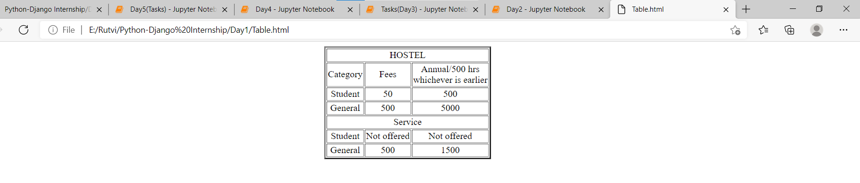

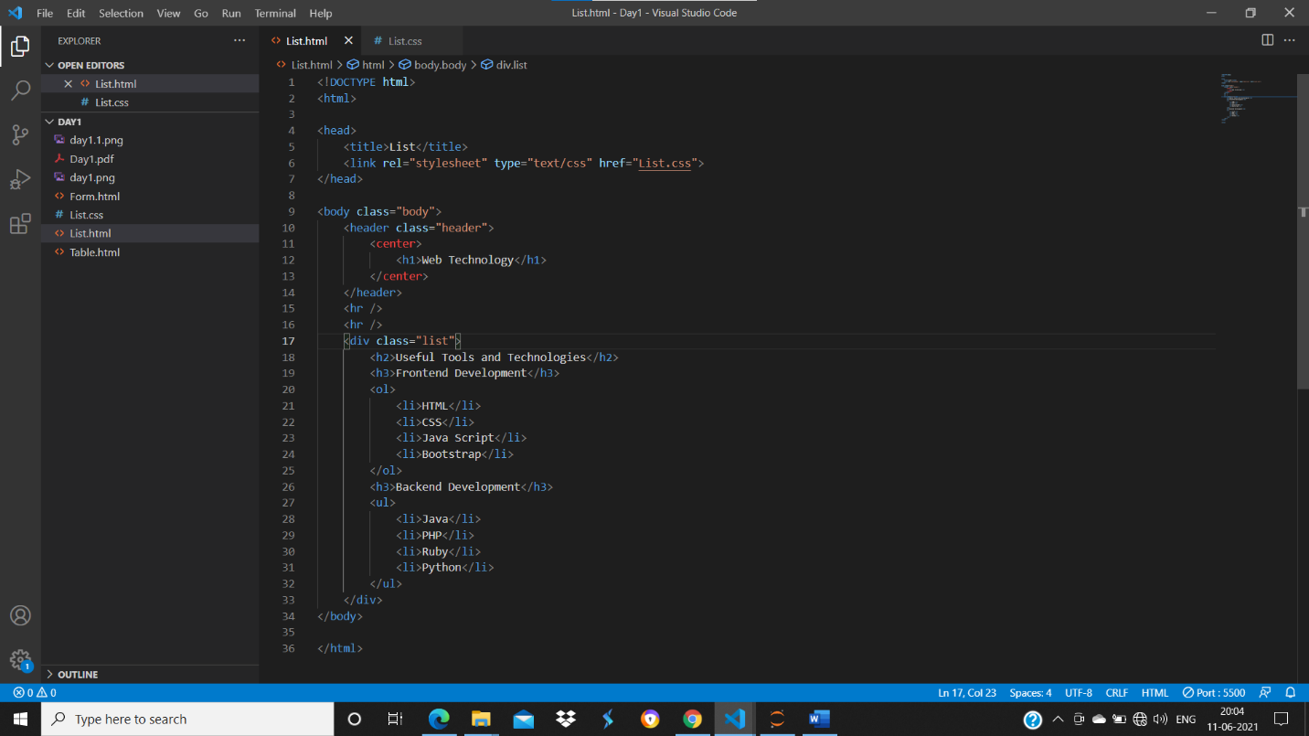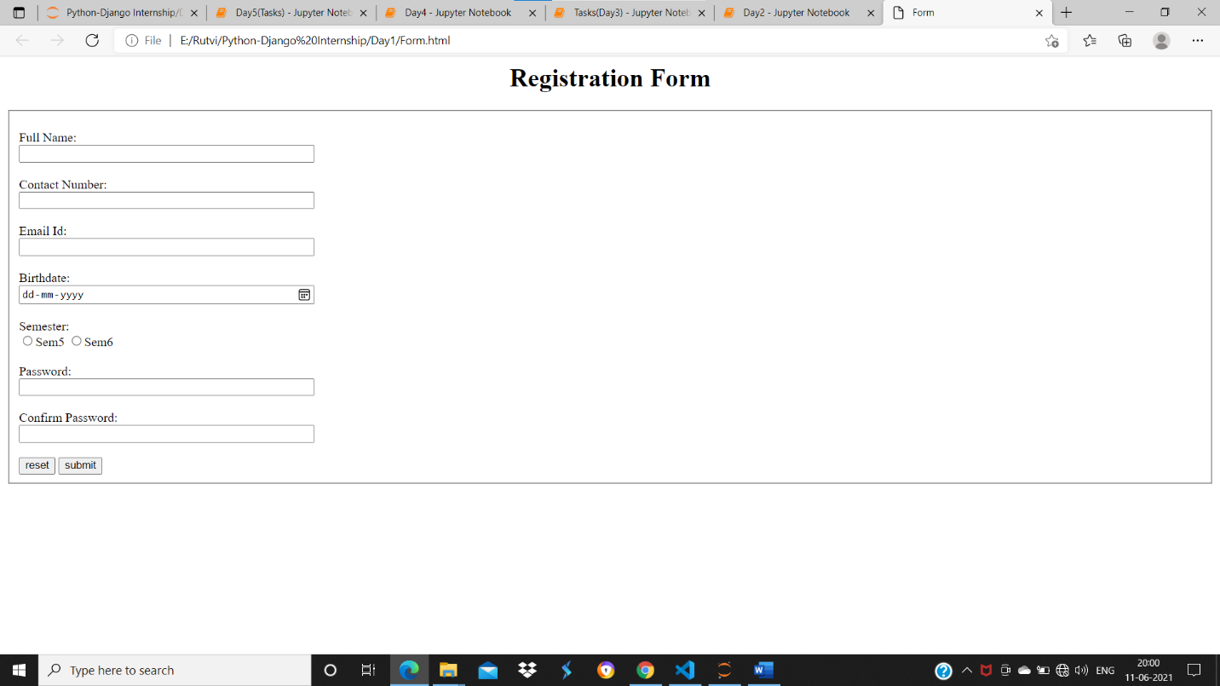

Day-2 (26/05/21):

On the second day of the internship, variables, various types of data types, and data structures such as Lists, Tuples, Dictionary, and their implementation was explained. Intending to build a strong understanding, some basic tasks had given based on the concepts.

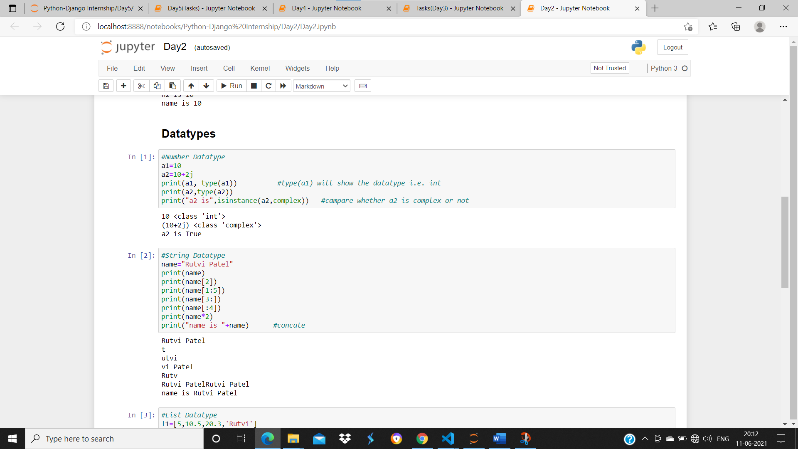

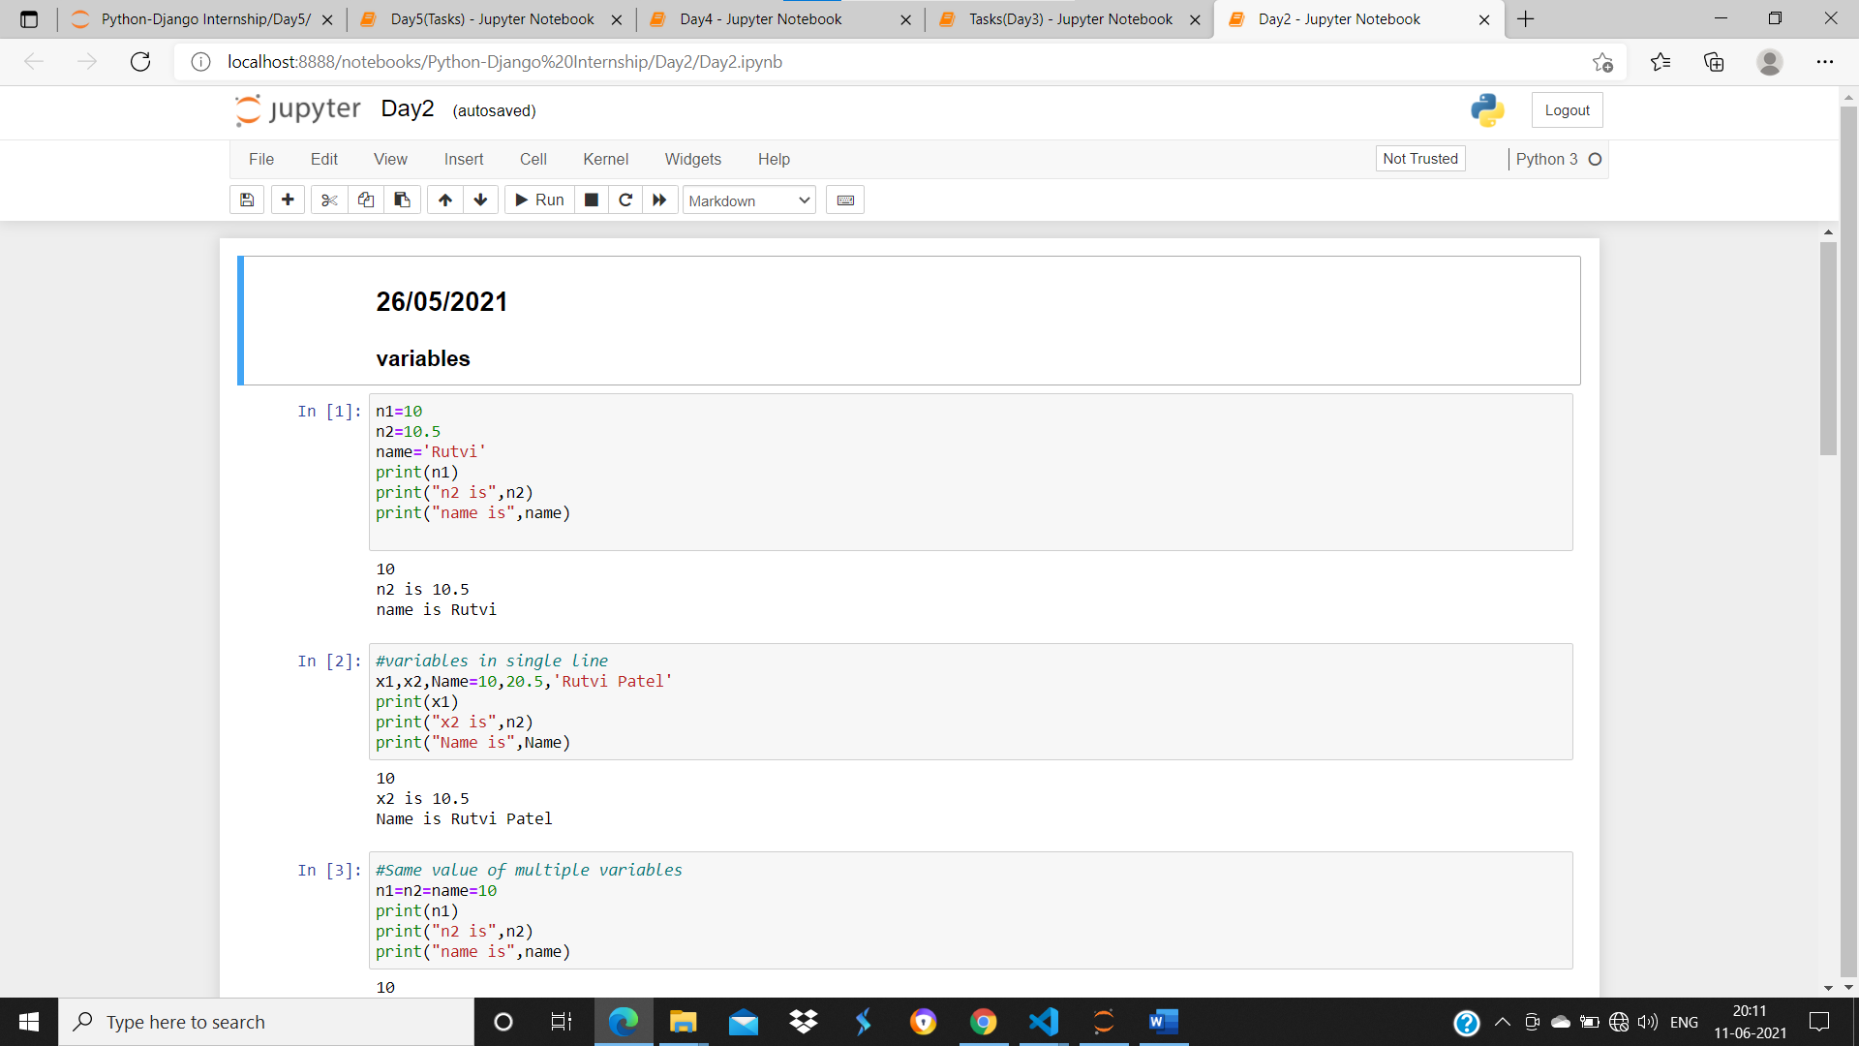

Day-3 (27/05/21):

On the third day of the internship, conditional statements, looping statements, Range function, Break & continue and pass statement, had explained. Some basic level programs had given as a task at the end of the session.

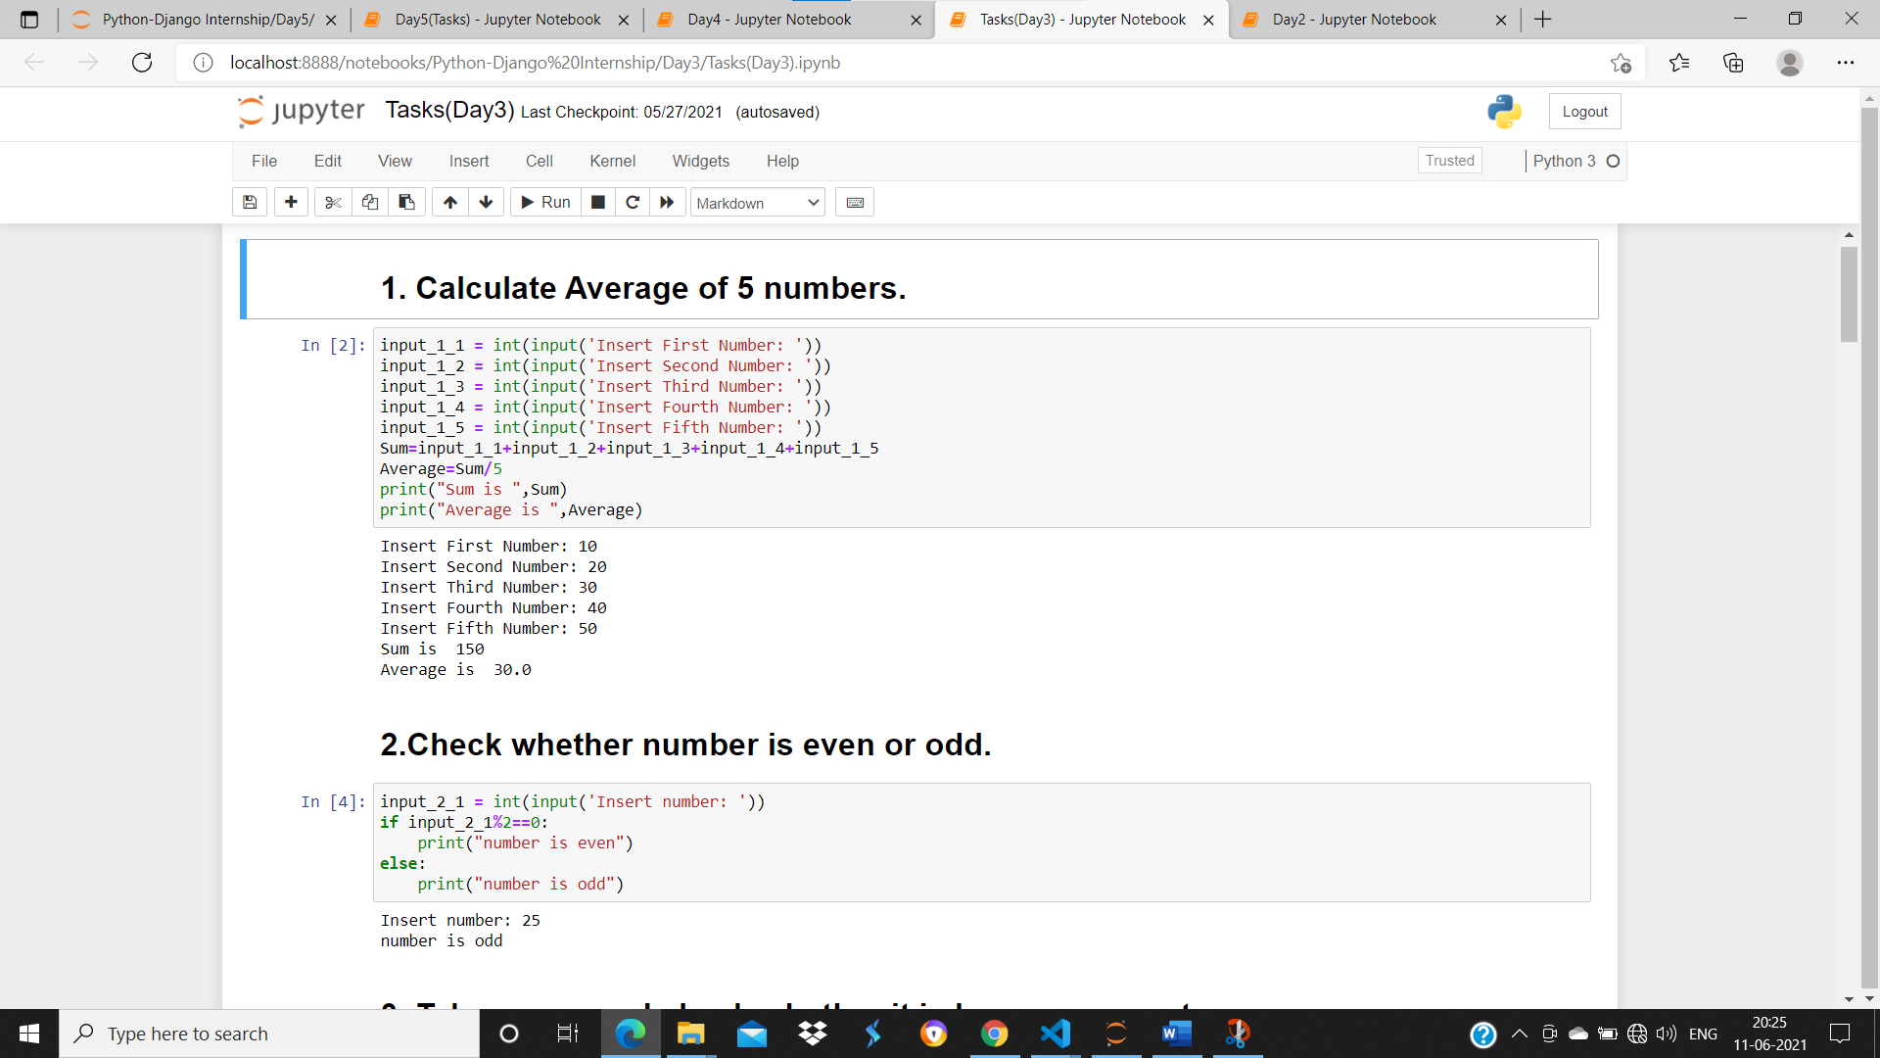

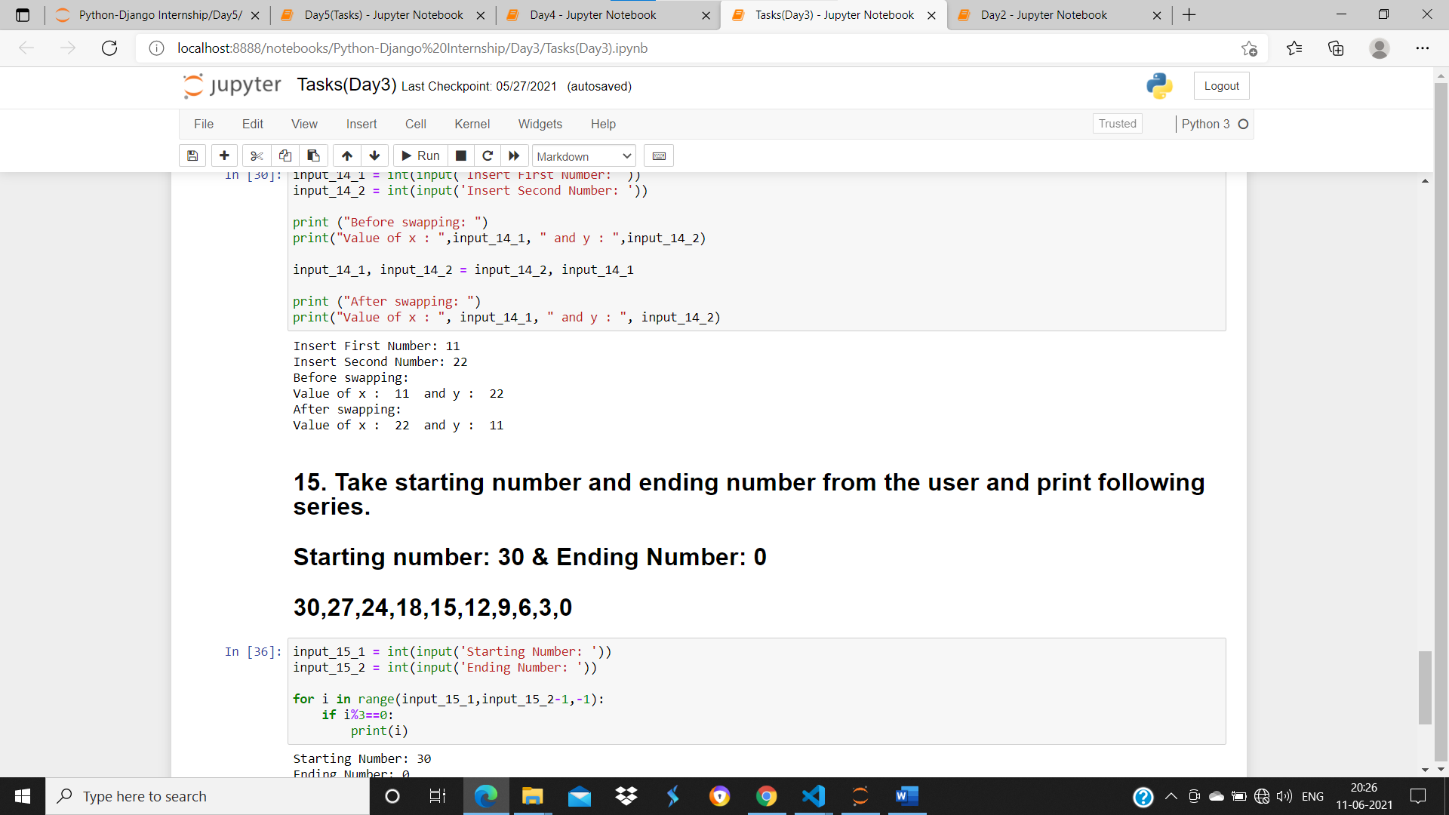

Day-4 (28/05/21):

On the fourth day of the training, User Defined Functions, types of function arguments, and their implementation was demonstrated by the instructor.

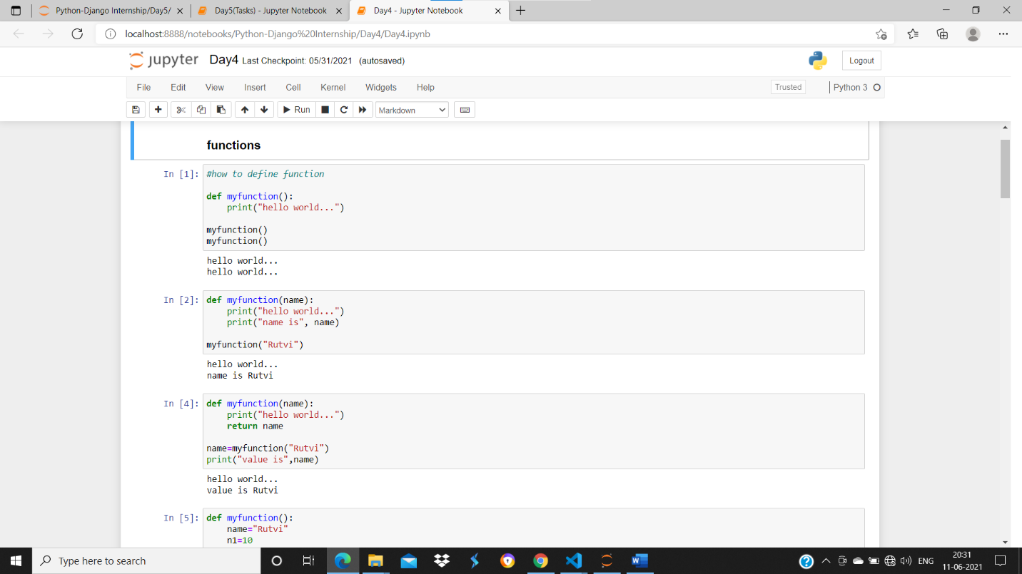

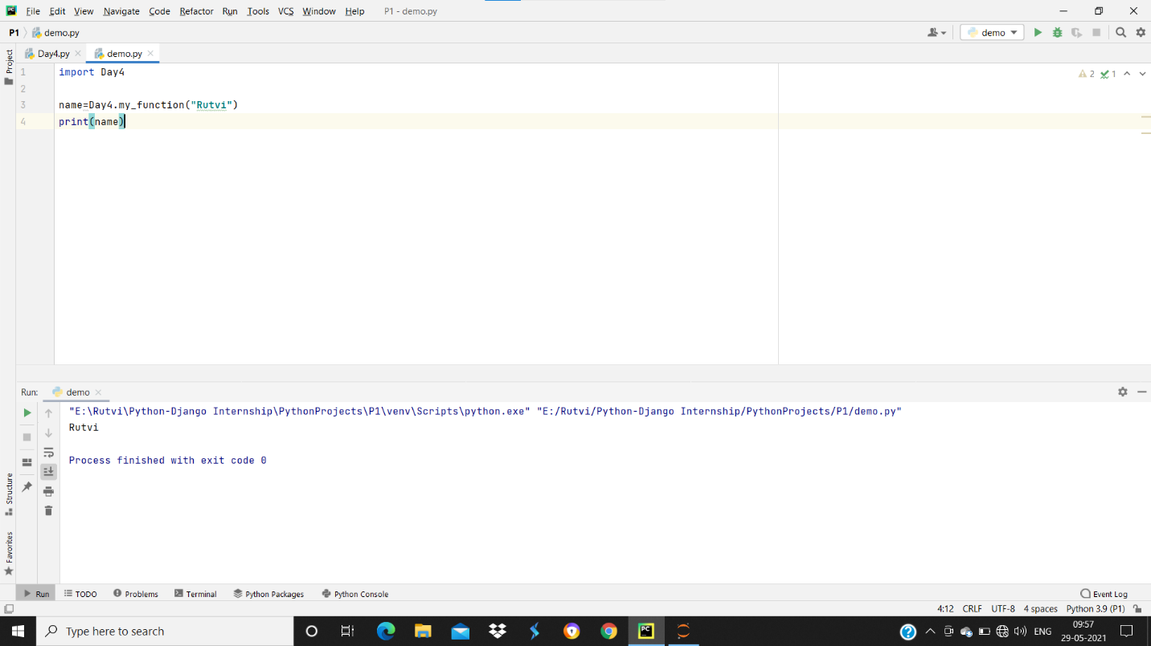

Day-5 (31/05/21):

On the fifth day (last day) of the Python training, OOPs concepts such as methods, functions, constructors, different types of inheritance, overriding method, and overloading method were explained.

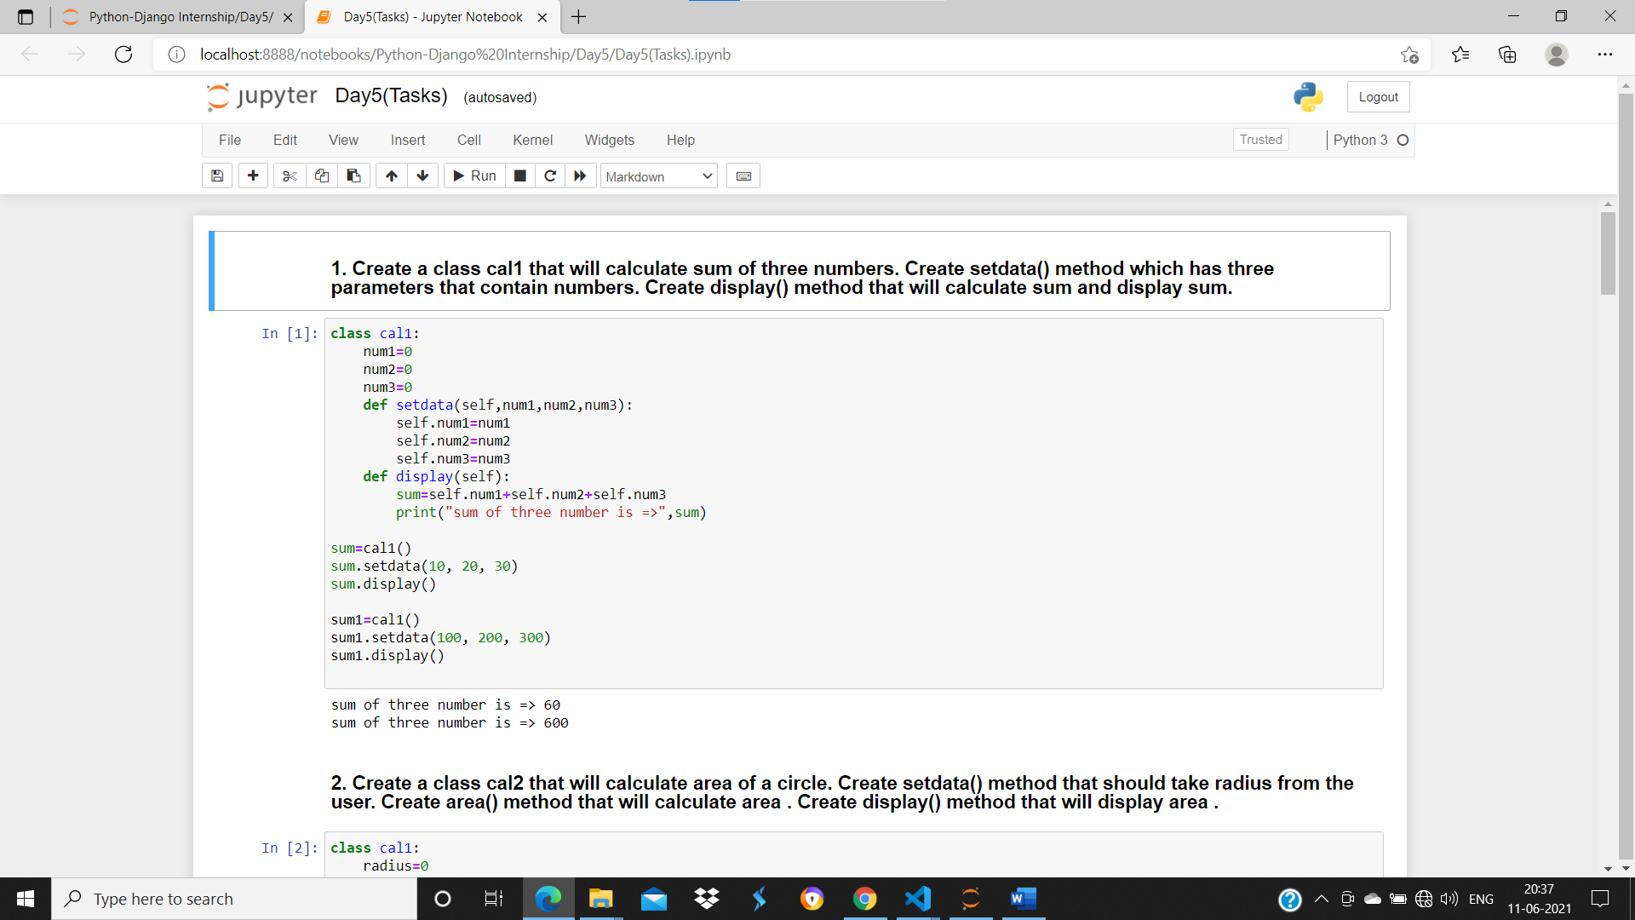

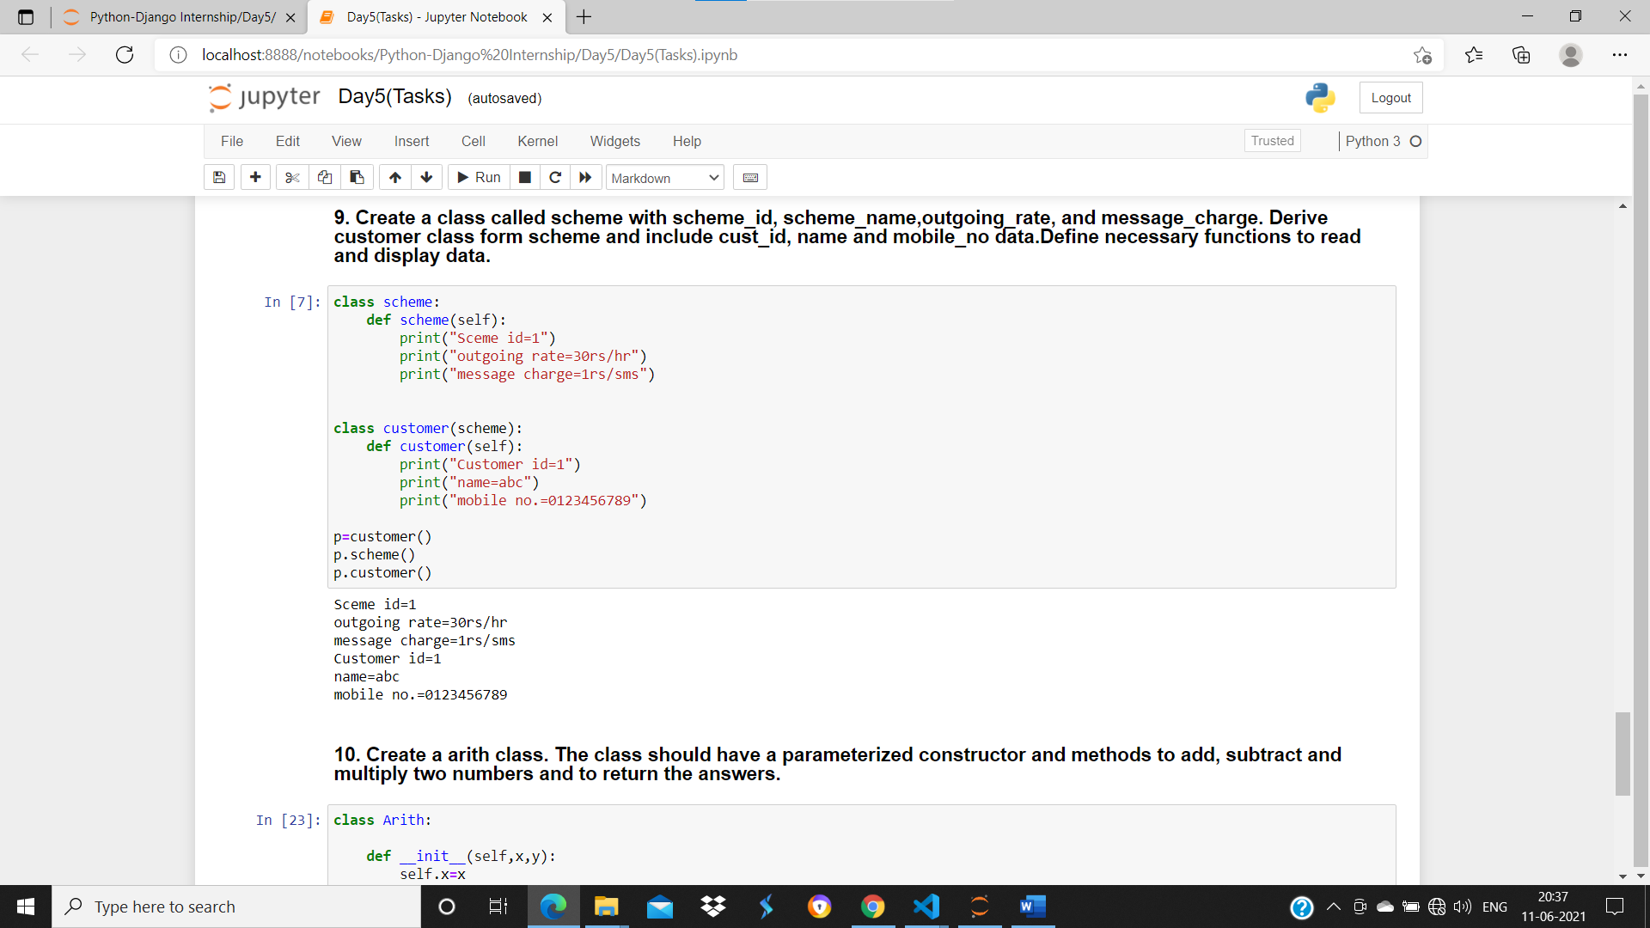

Day-6 (01/06/21):

On the sixth day of the internship and the first day of the Django training, the instructor had given a complete overview of Django, how to use it and how it can be implemented in numerous real-world projects.

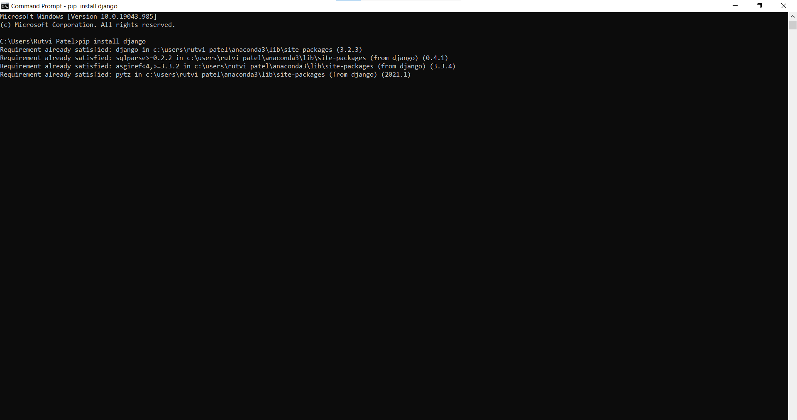

Day-7 (02/06/21):

On the seventh day of the internship, the instructor had explained how to create a new project and new application in Django, how to set URLs and how-to code. Along with this, he had discussed how to access the database and Django administration panel.

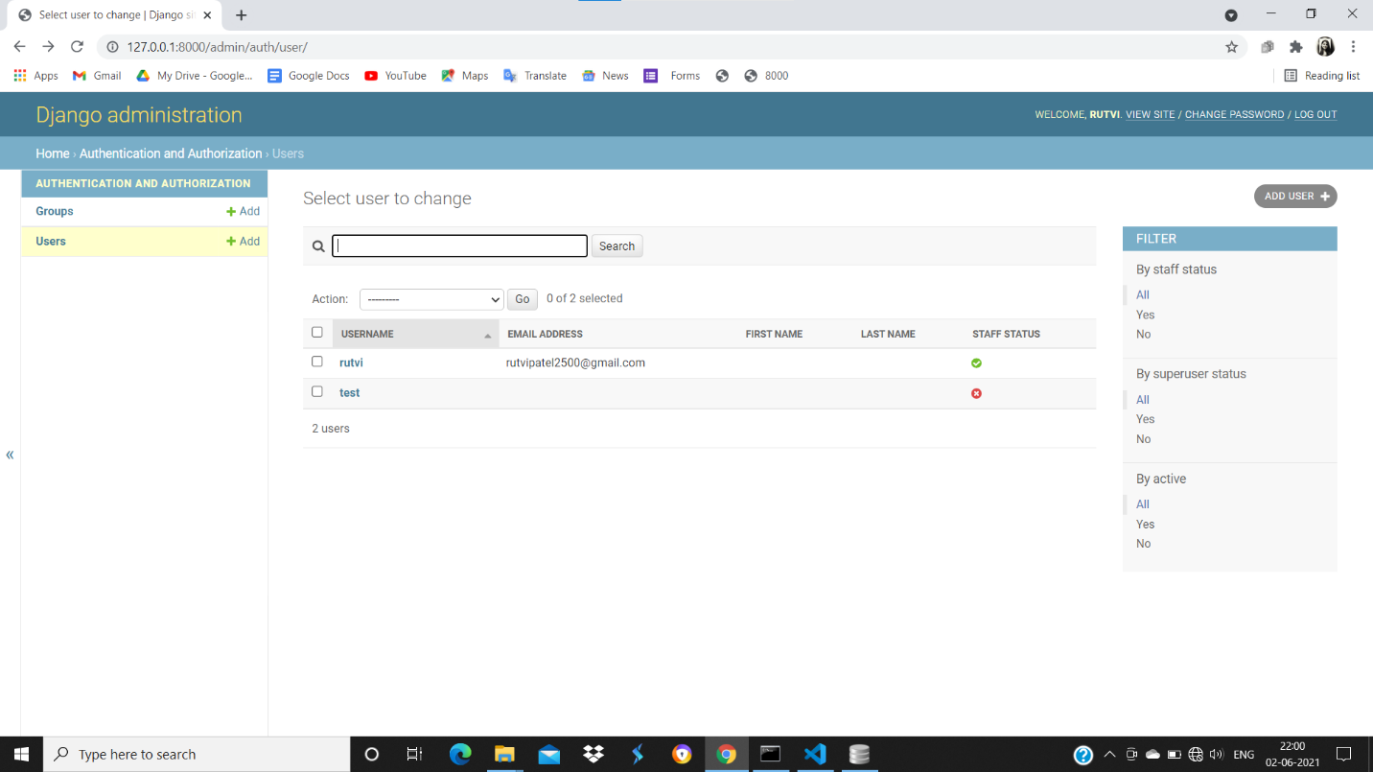

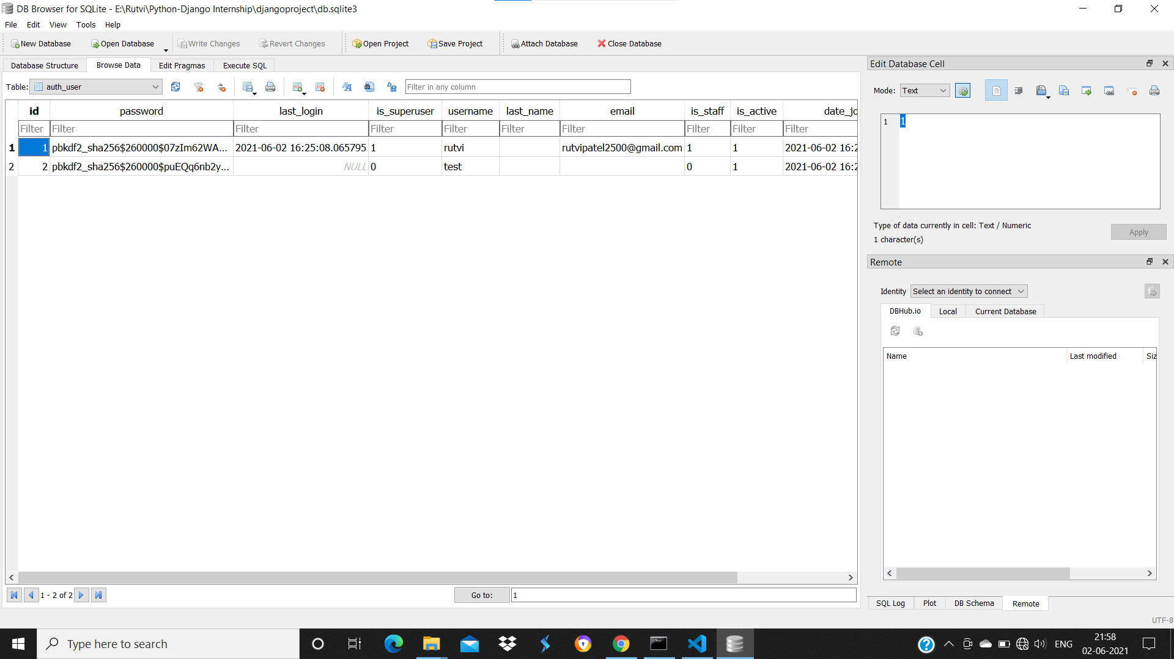

Day-8 (03/06/21):

On the eighth day of the internship, the instructor had provided a complete explanation on how to load the CSS theme in Django.

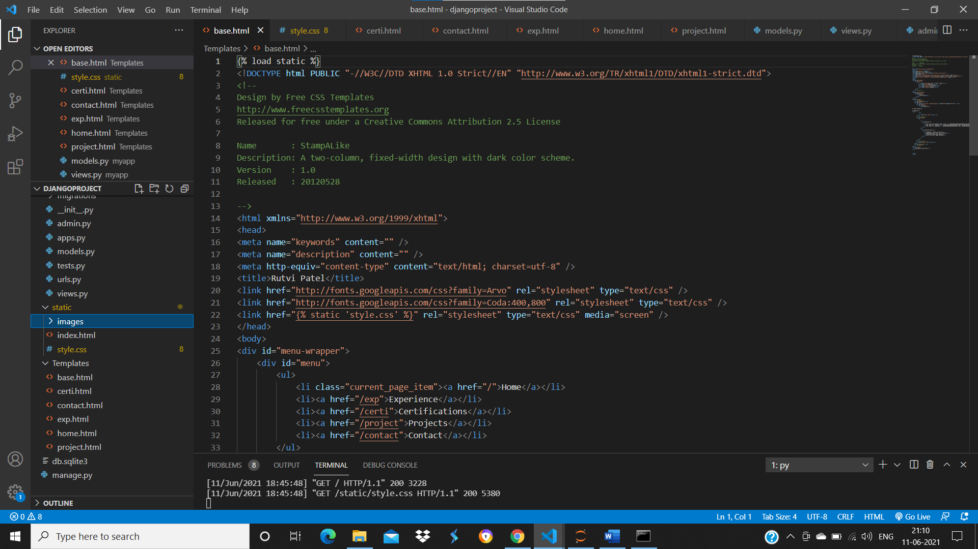

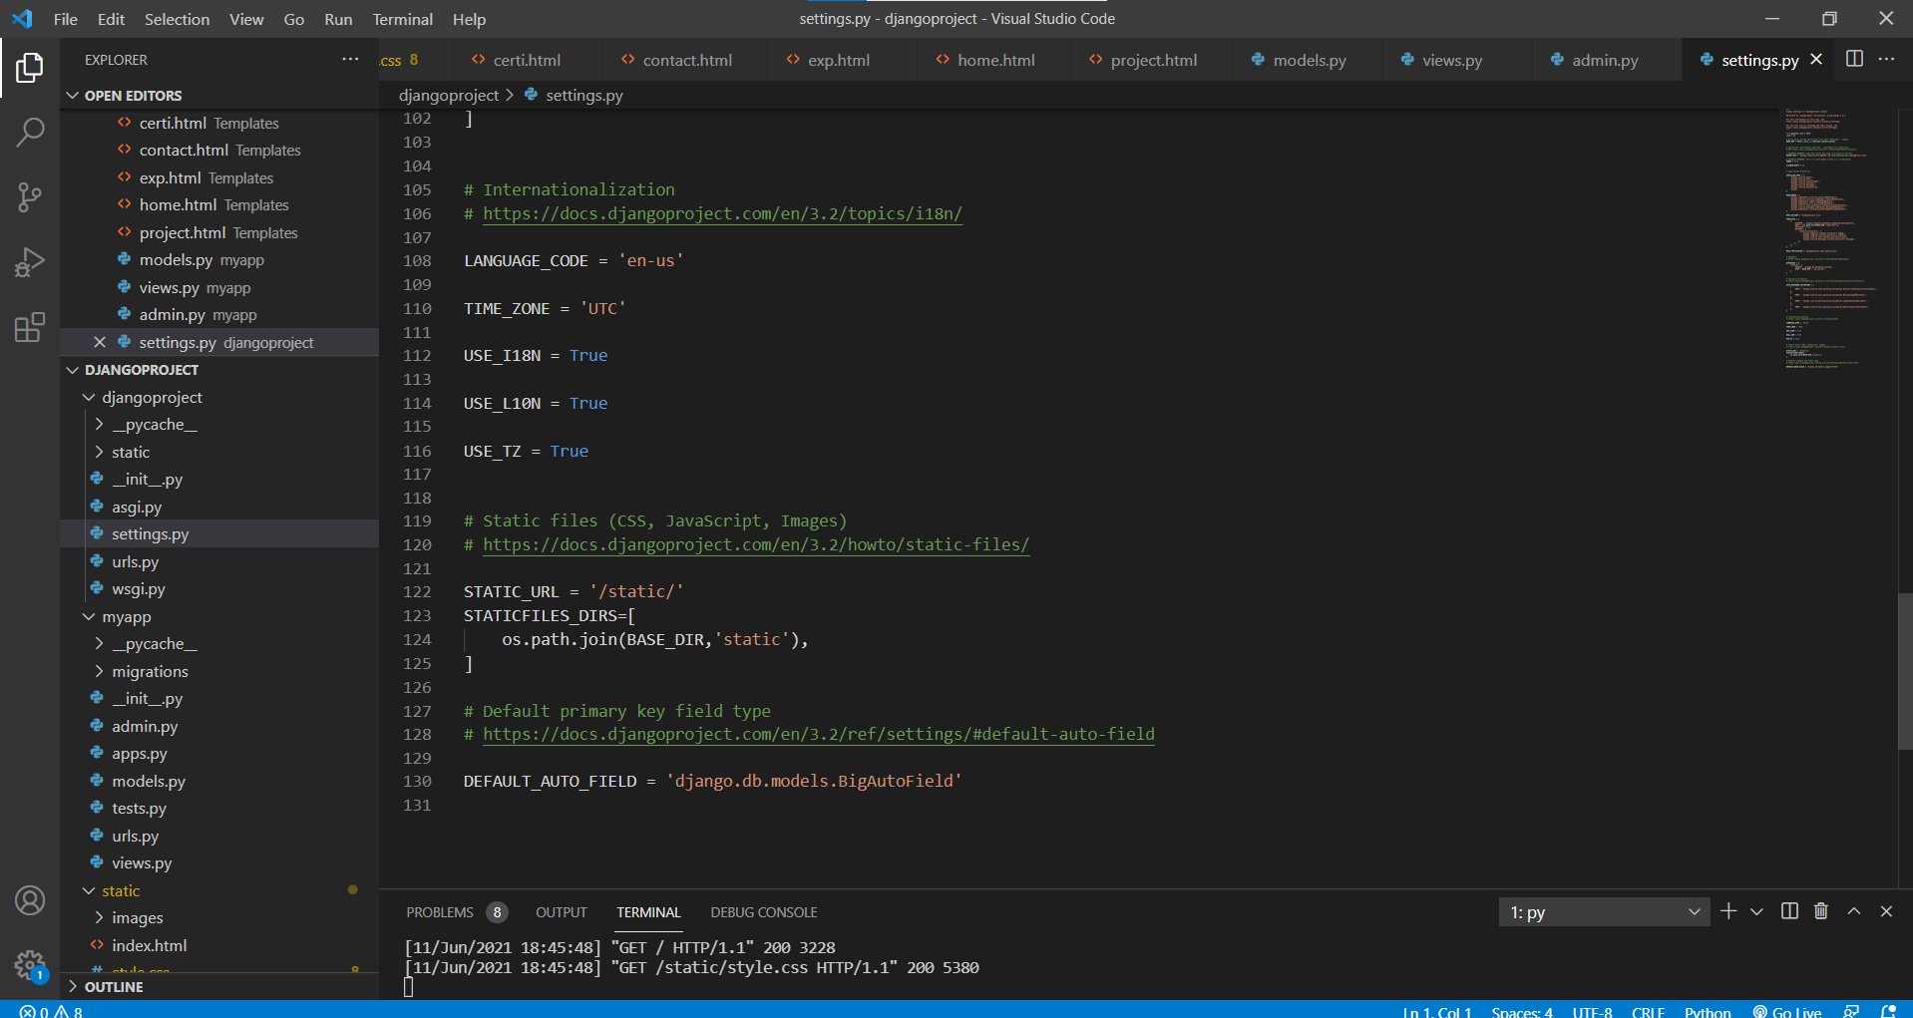

Day-9 (04/06/21):

On the ninth day of the internship, the instructor had explained about Form creation in Django and applying Get Post Methods on it.

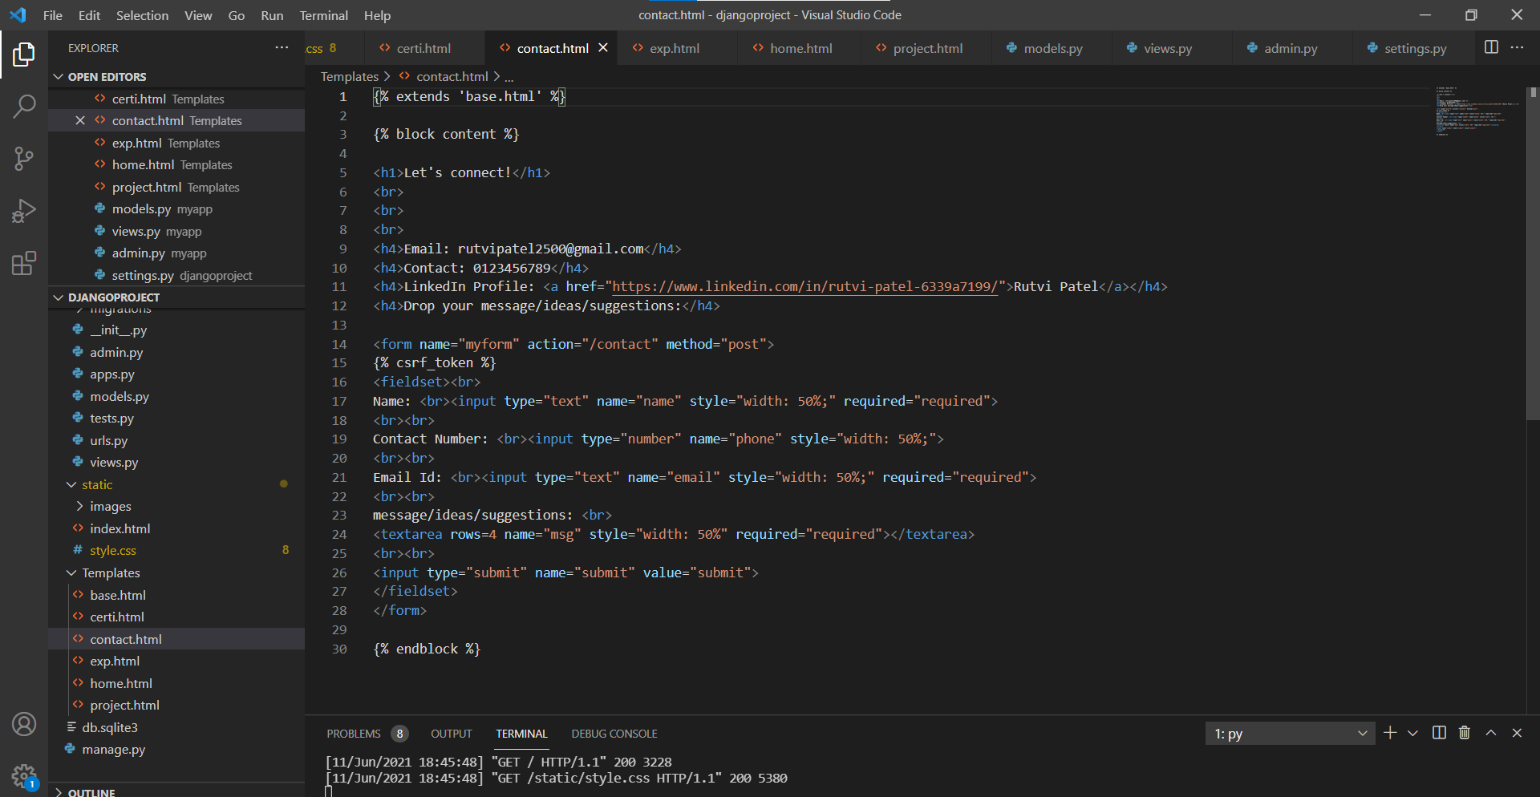

Day-10 (07/06/21):

On the last day of the internship, the instructor had explained the database connectivity using Django Admin Panel. Moreover, the project was assigned to all the students intending to evaluate their learning.

